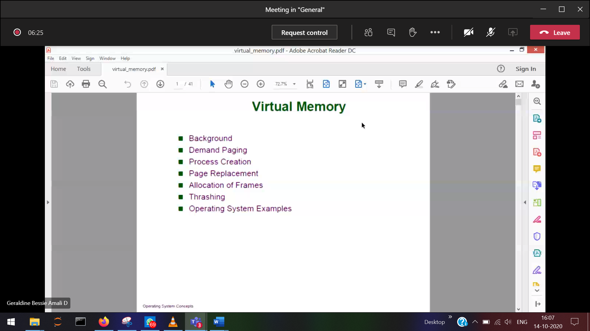

Allows the logical address space even bigger than the physical memory

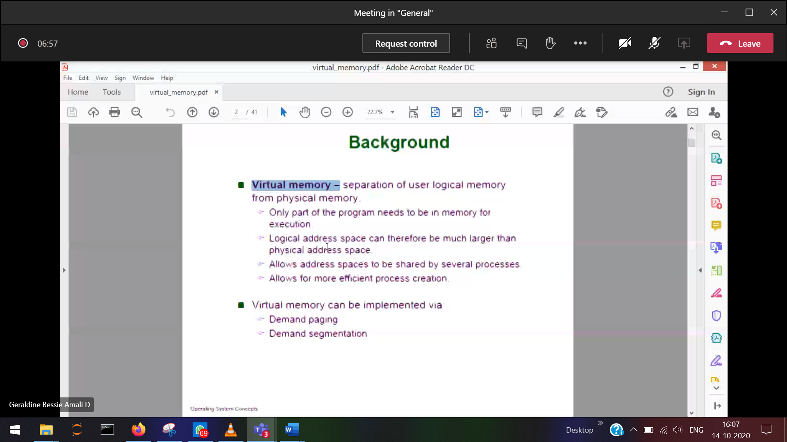

Dividing a number by 0

Try 🡪 any wrong thing given as input instead of sending to the processor, it will go to the catch

Catch

When-ever a program executes it is not necessary that the complete program resides in the main-memory, the part which executes that only will reside in memory.   
Switch 🡪 default (will/will not execute)  
try 🡪 catch (will/will not execute)

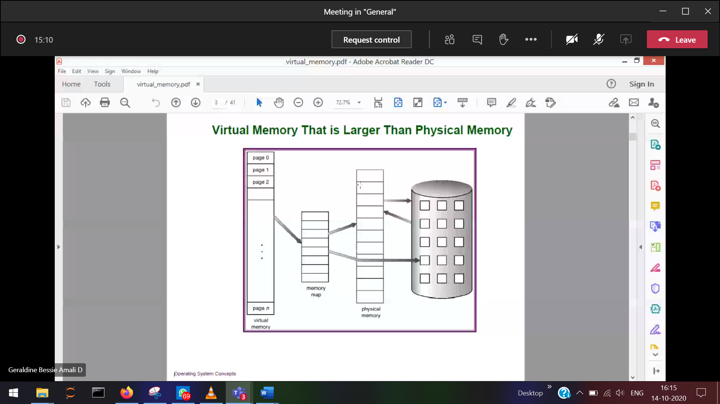

In virtual memory concept

logic memory is larger than physical memory

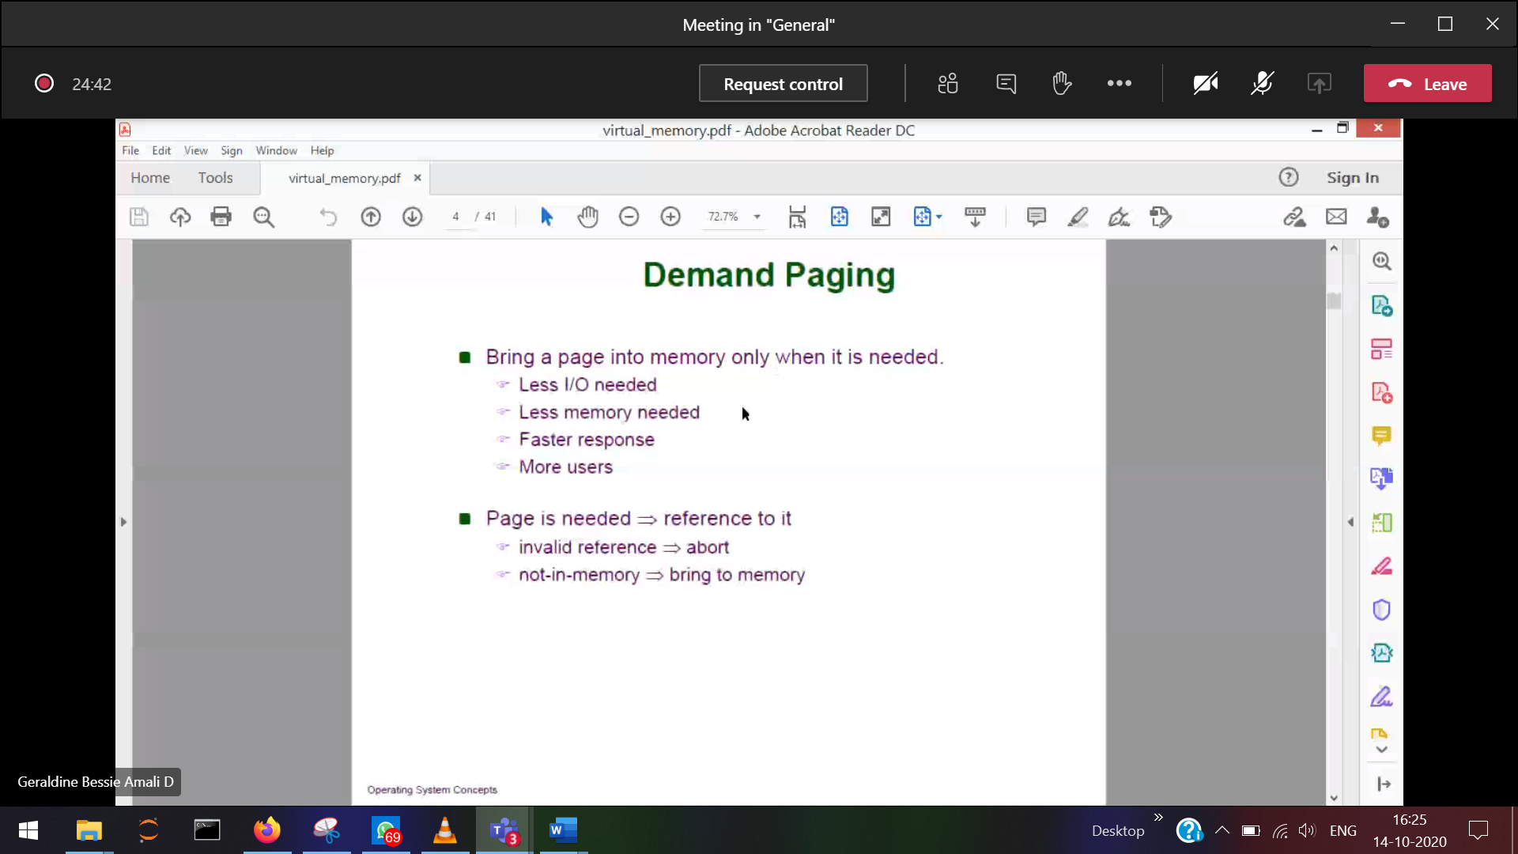

When the CPU requested page is not in physical memory, it will search in the secondary memory and then it is taken into RAM,

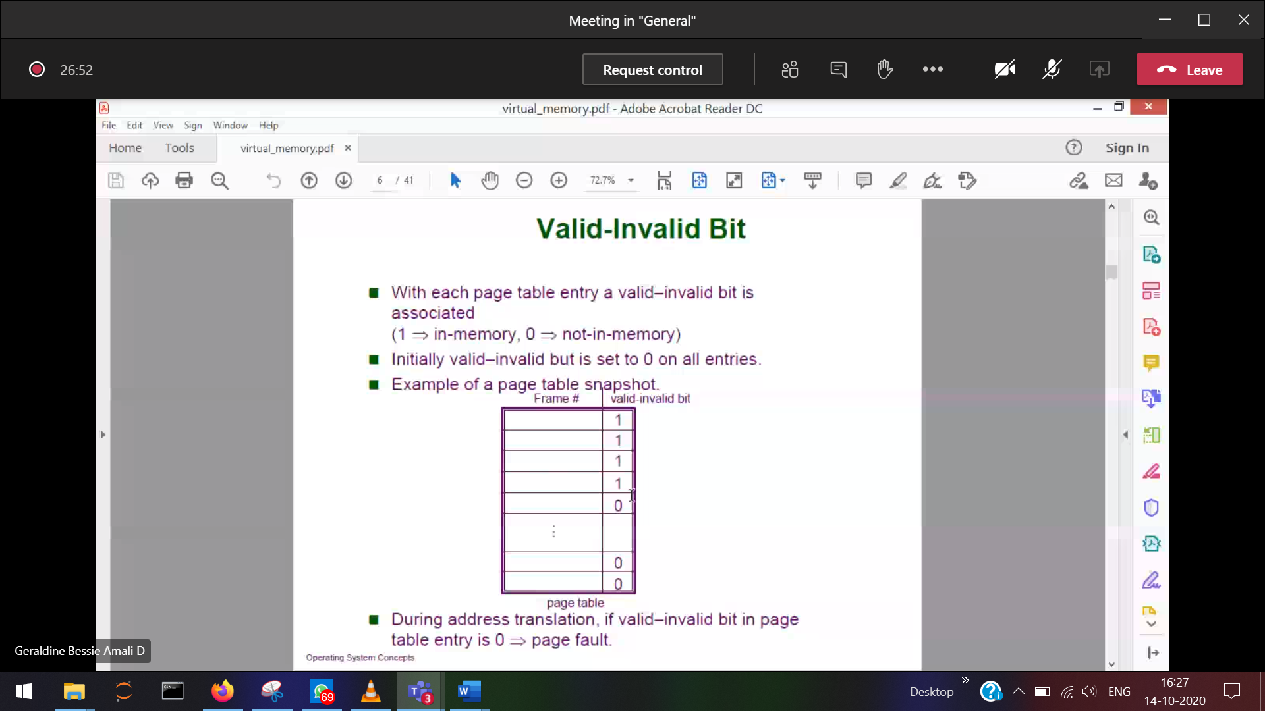

CPU generating a reference to a page which is not in the main memory 0)

Present 1)

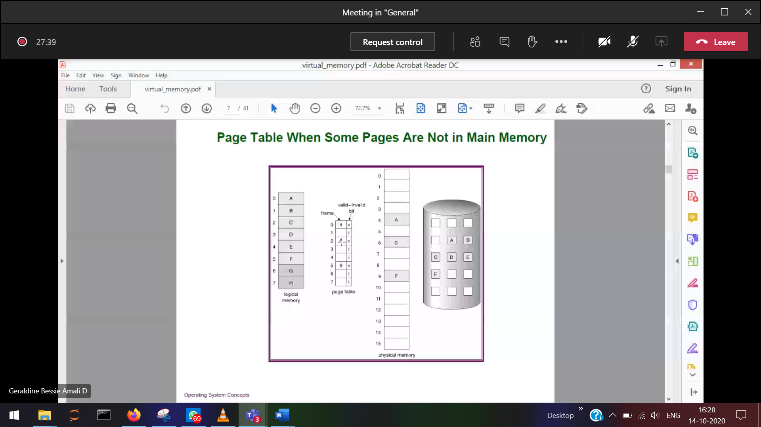

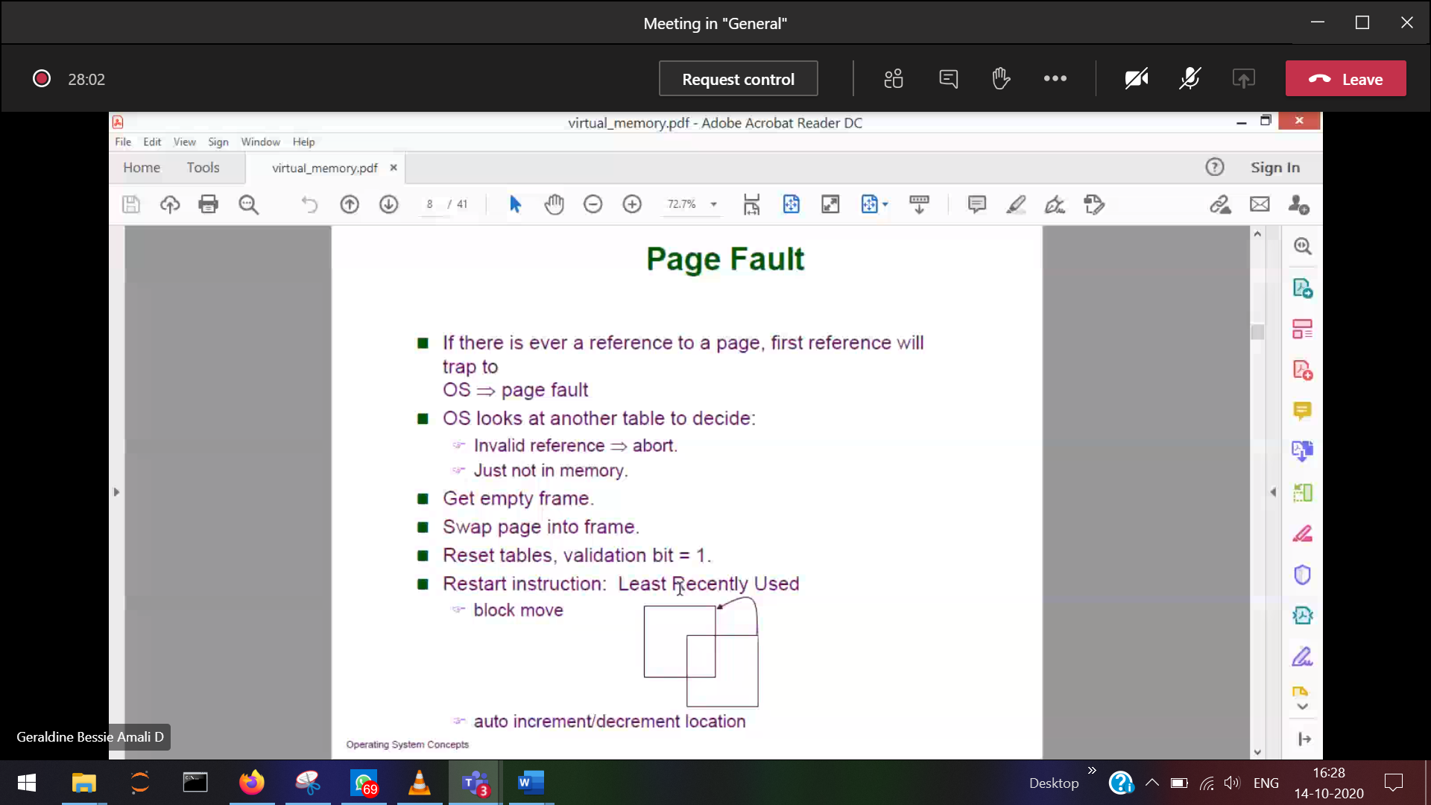

Invalid reference 🡪 Not at all present   
valid reference 🡪 inside the HD, should bring to the Ram

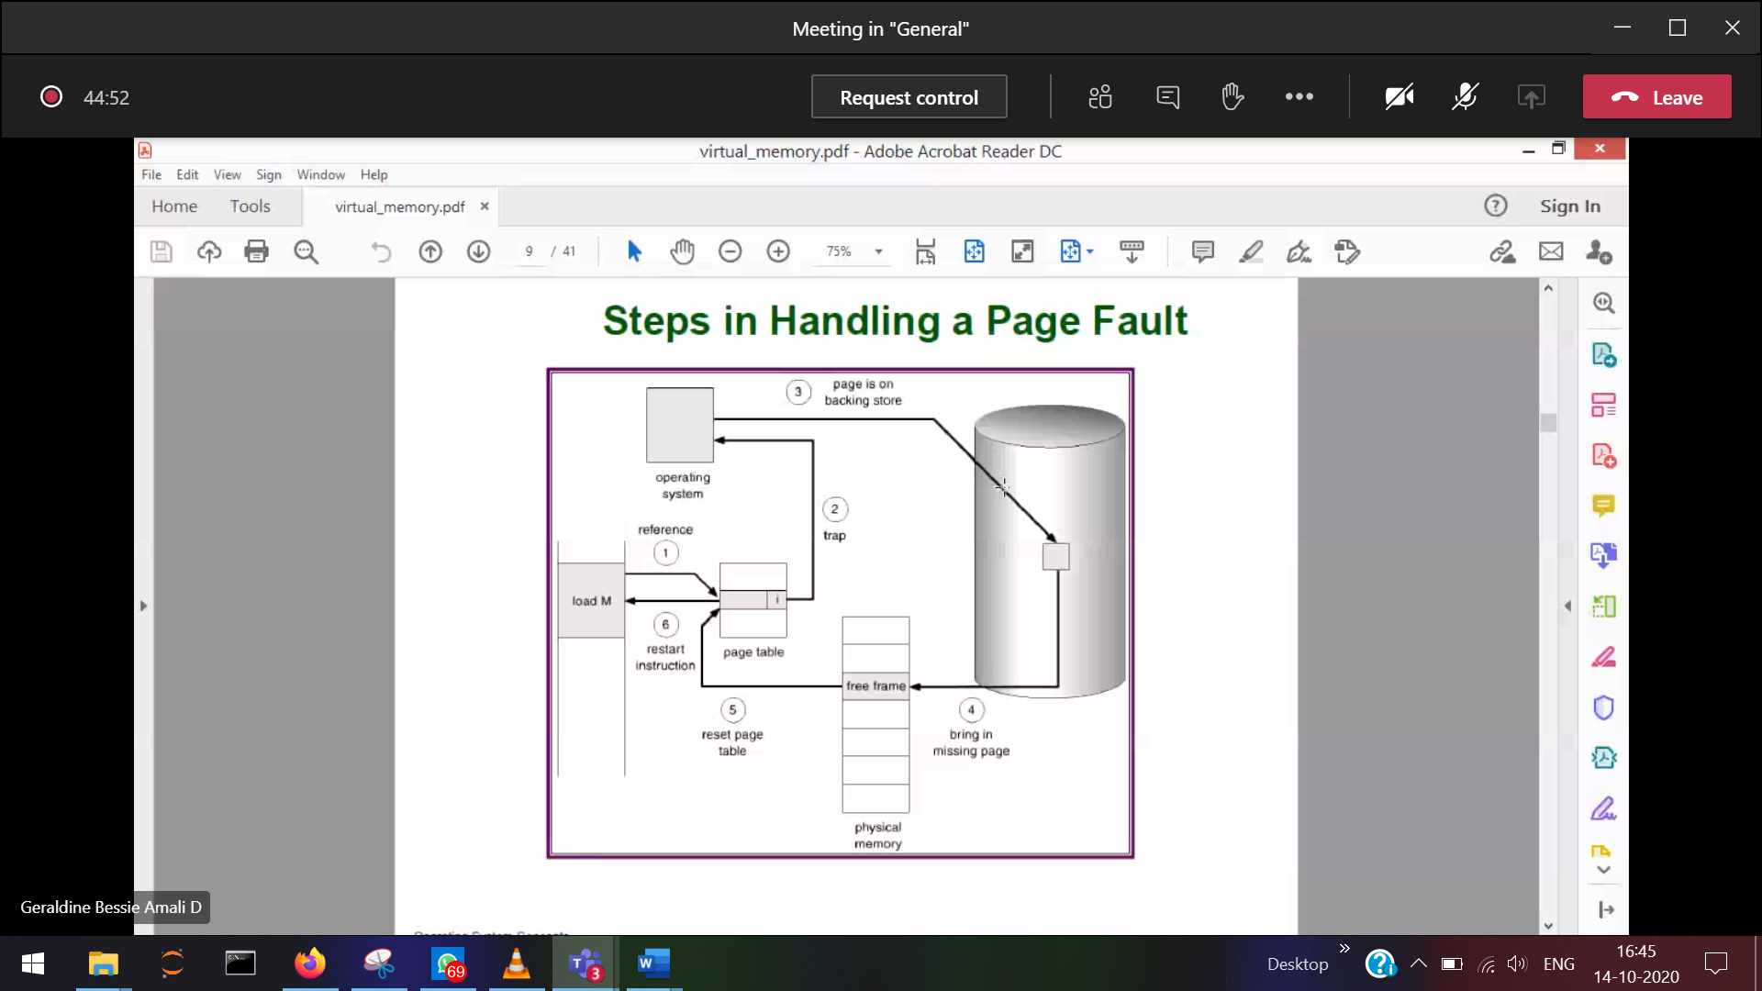

Steps to handle Page fault ( is not present in the RAM)  
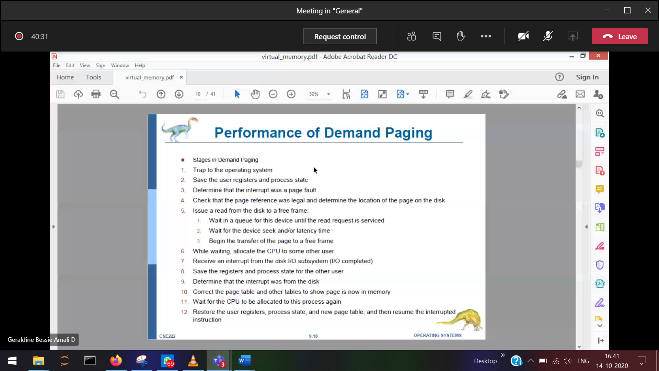

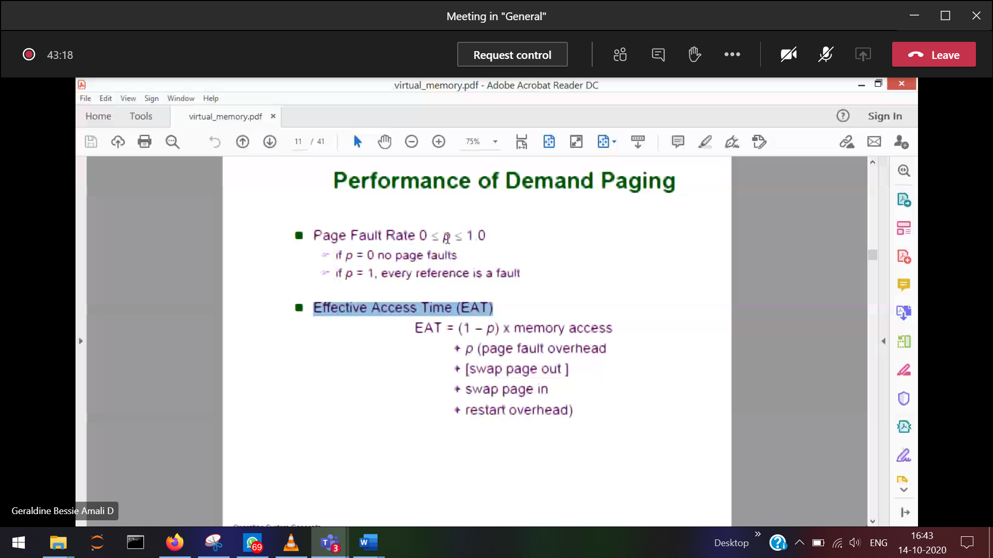

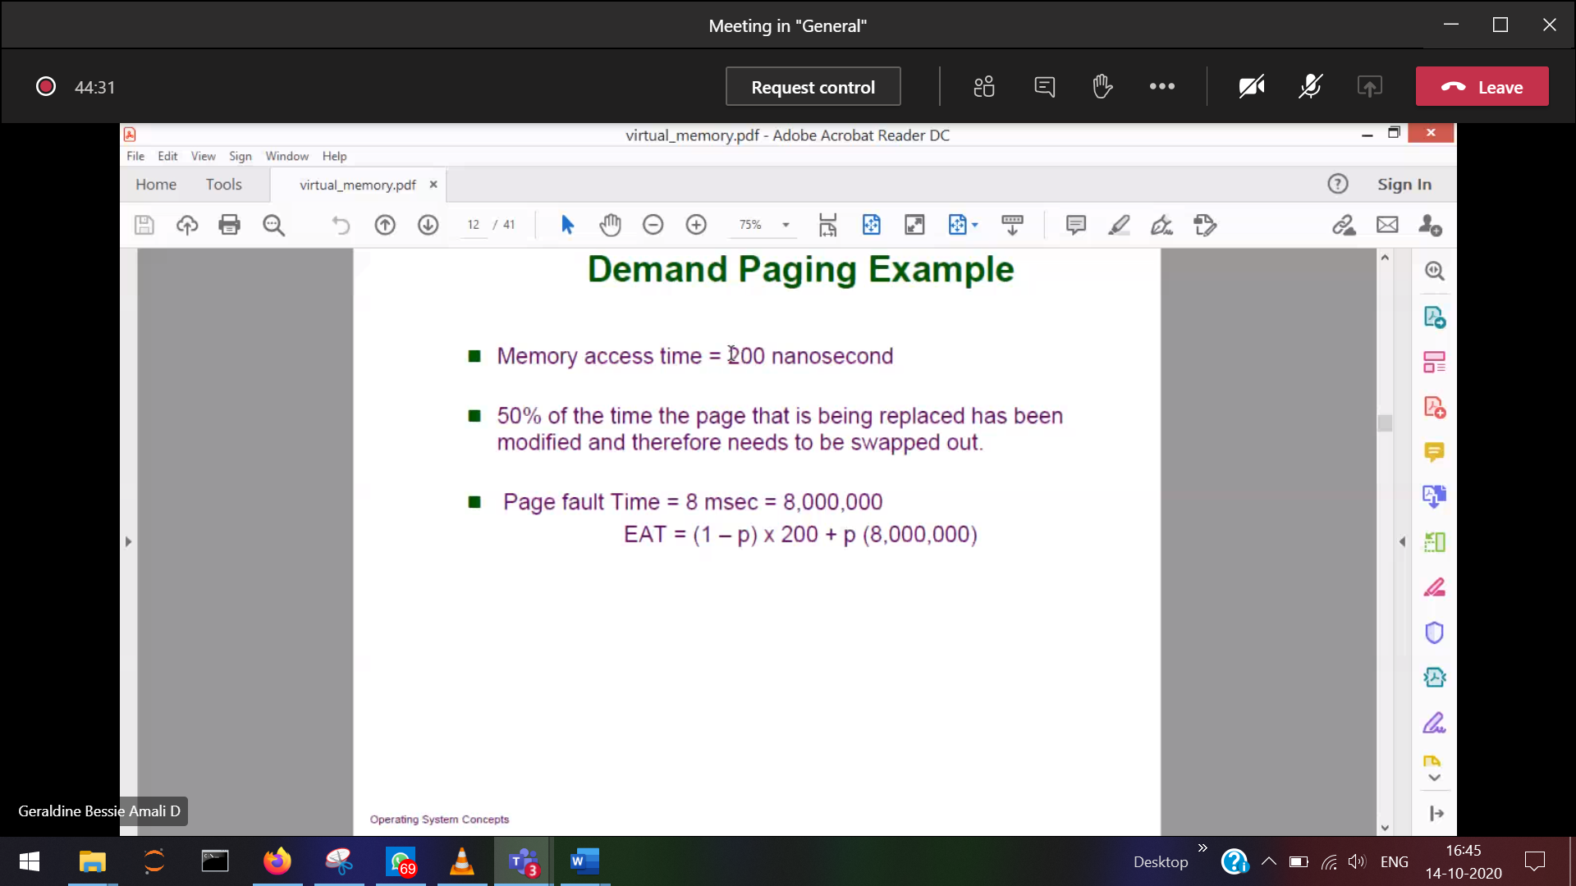

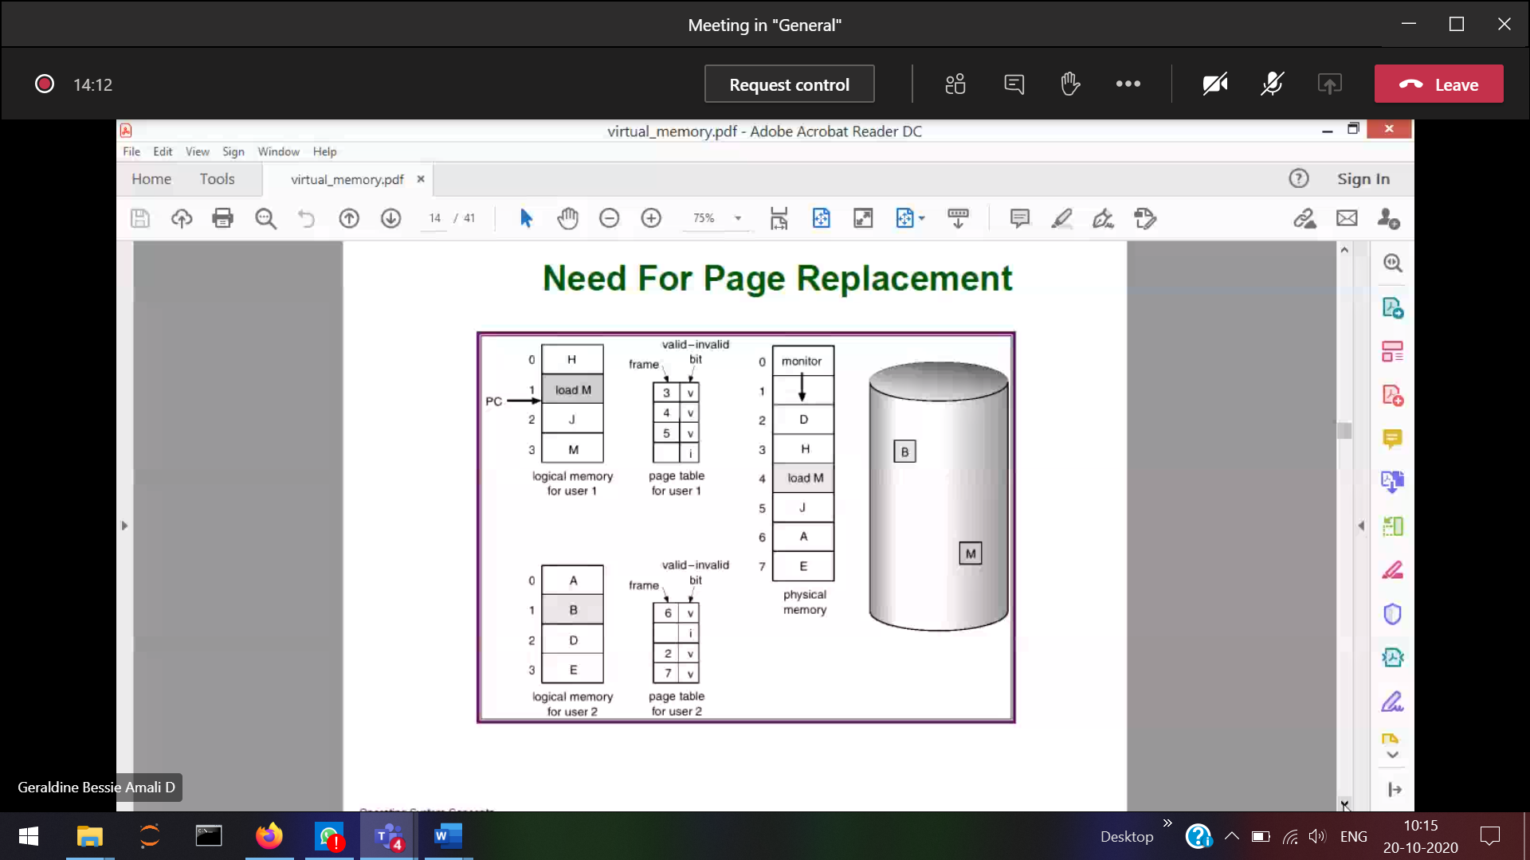

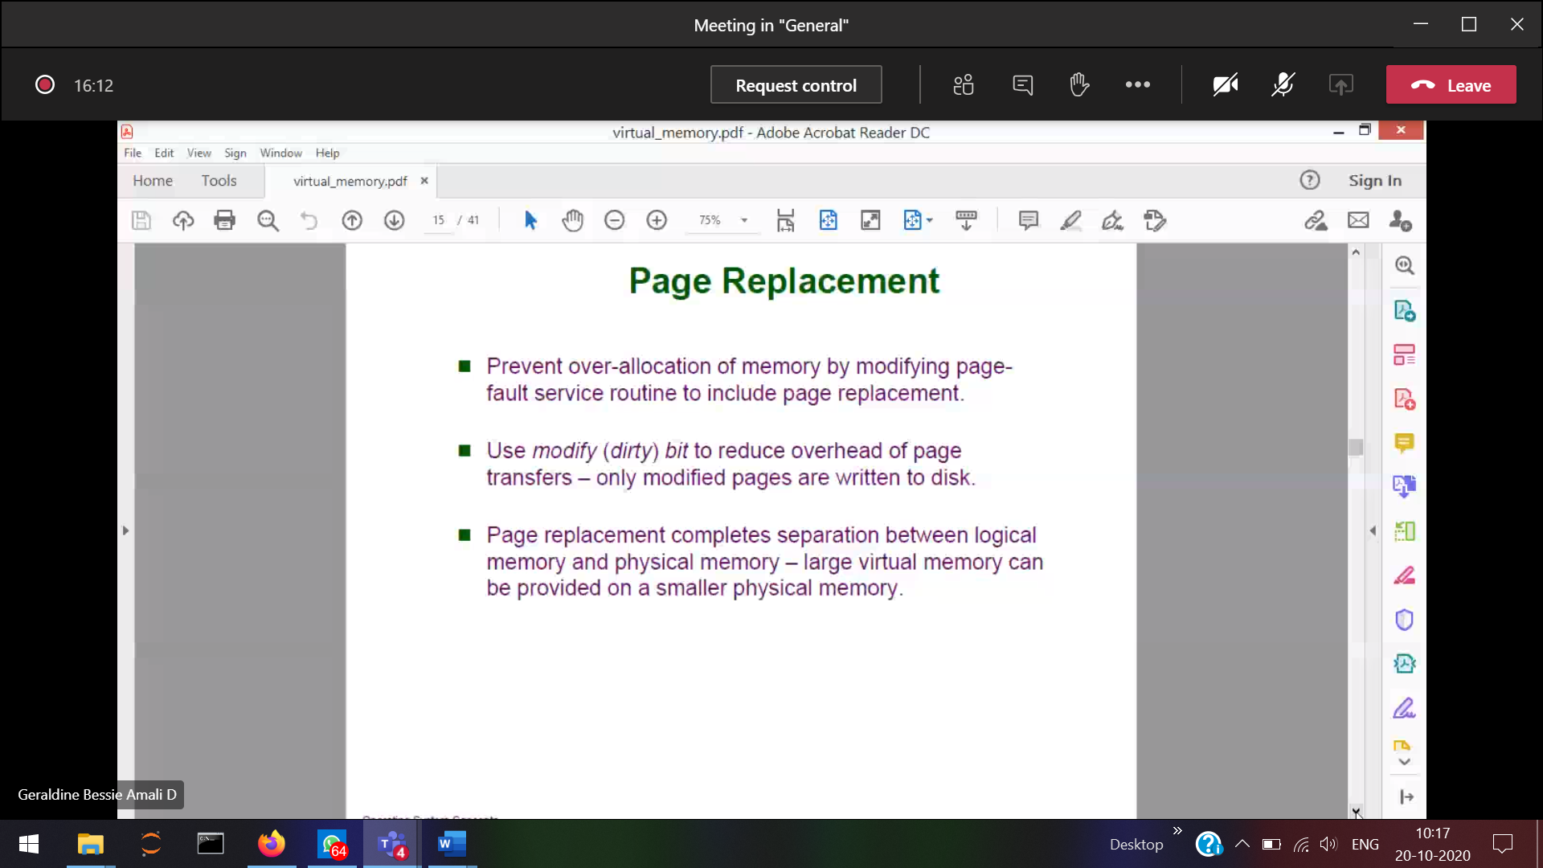

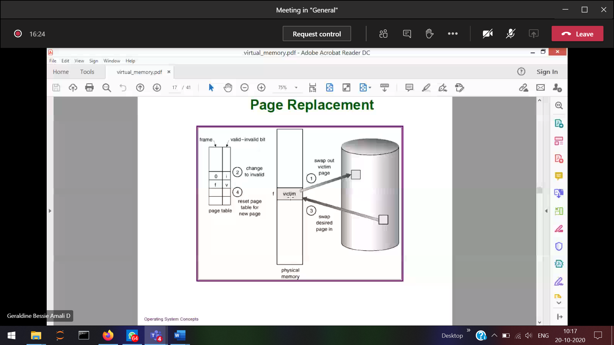

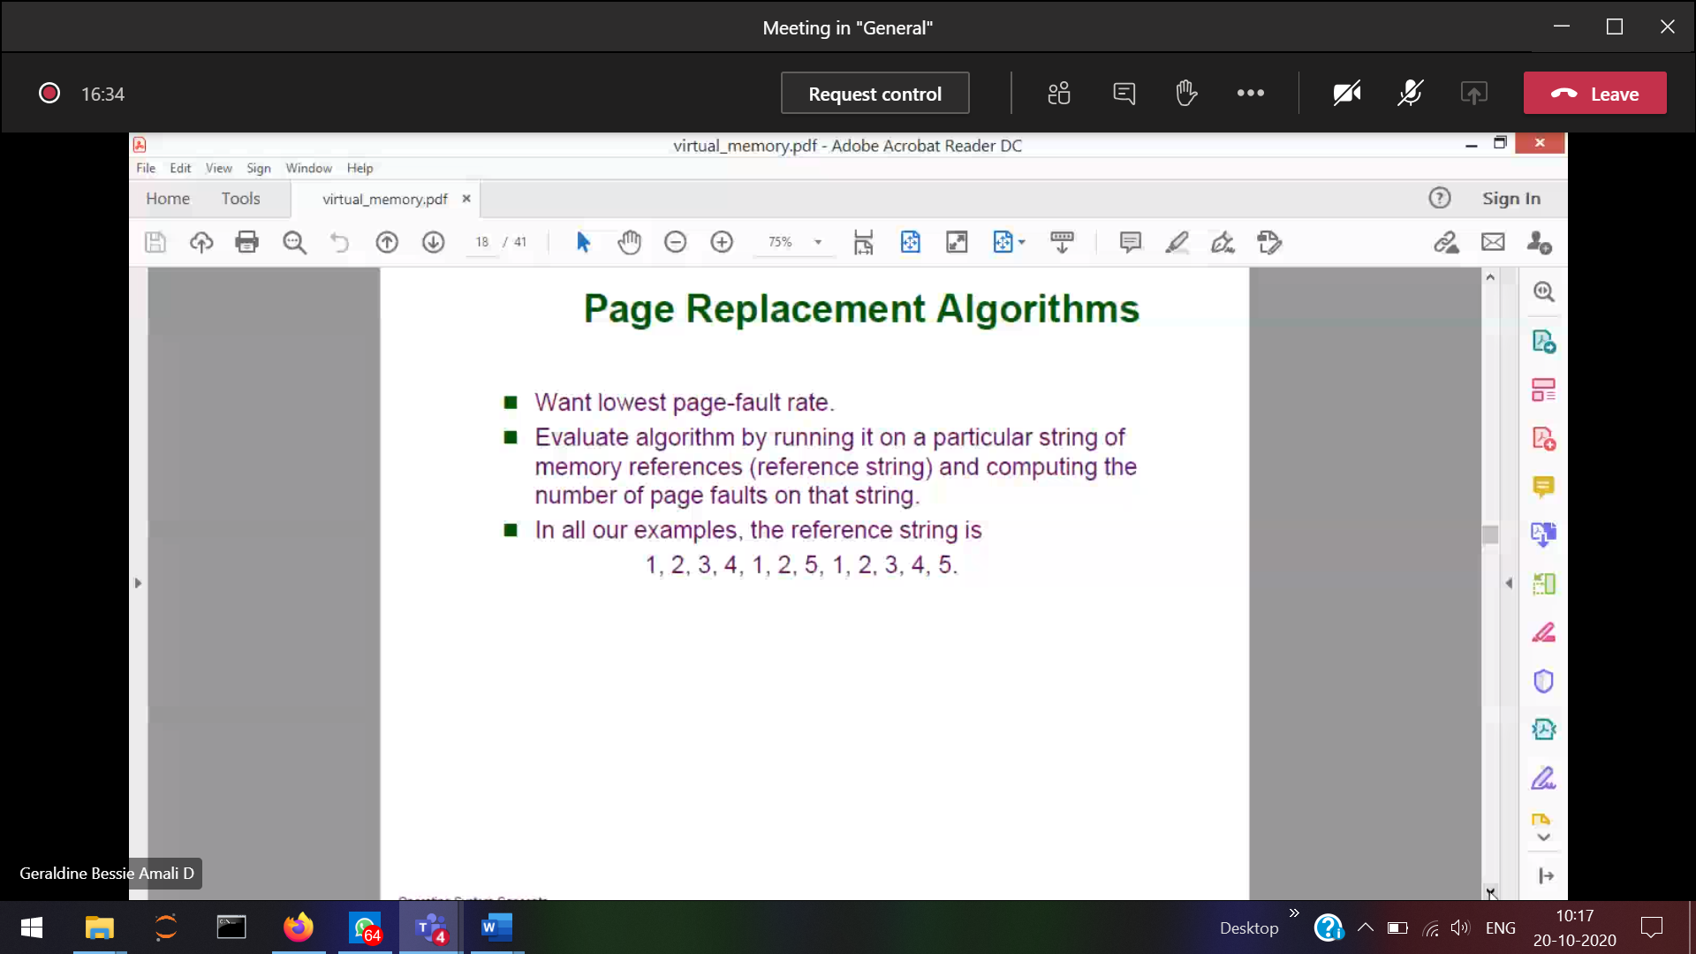

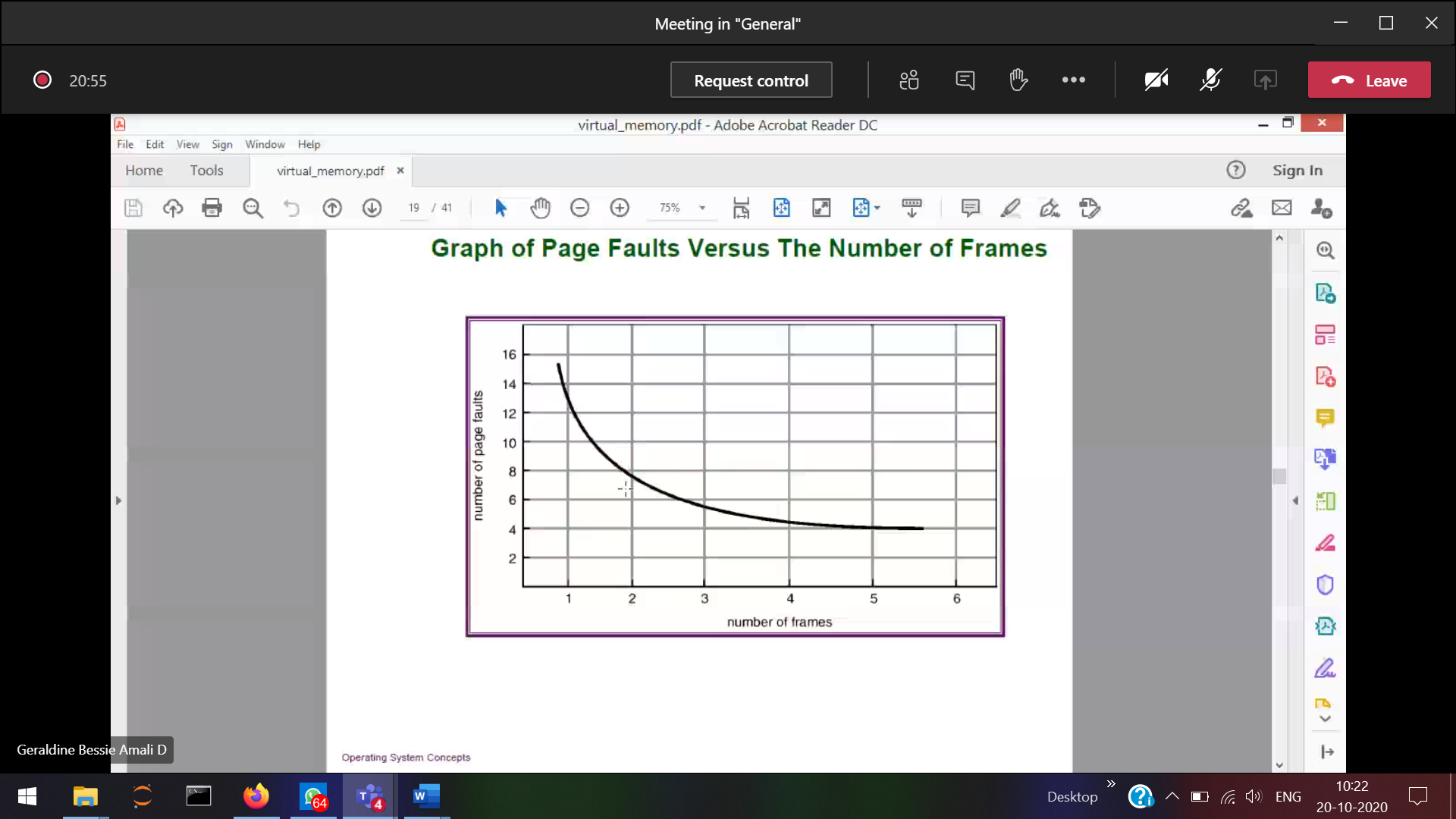

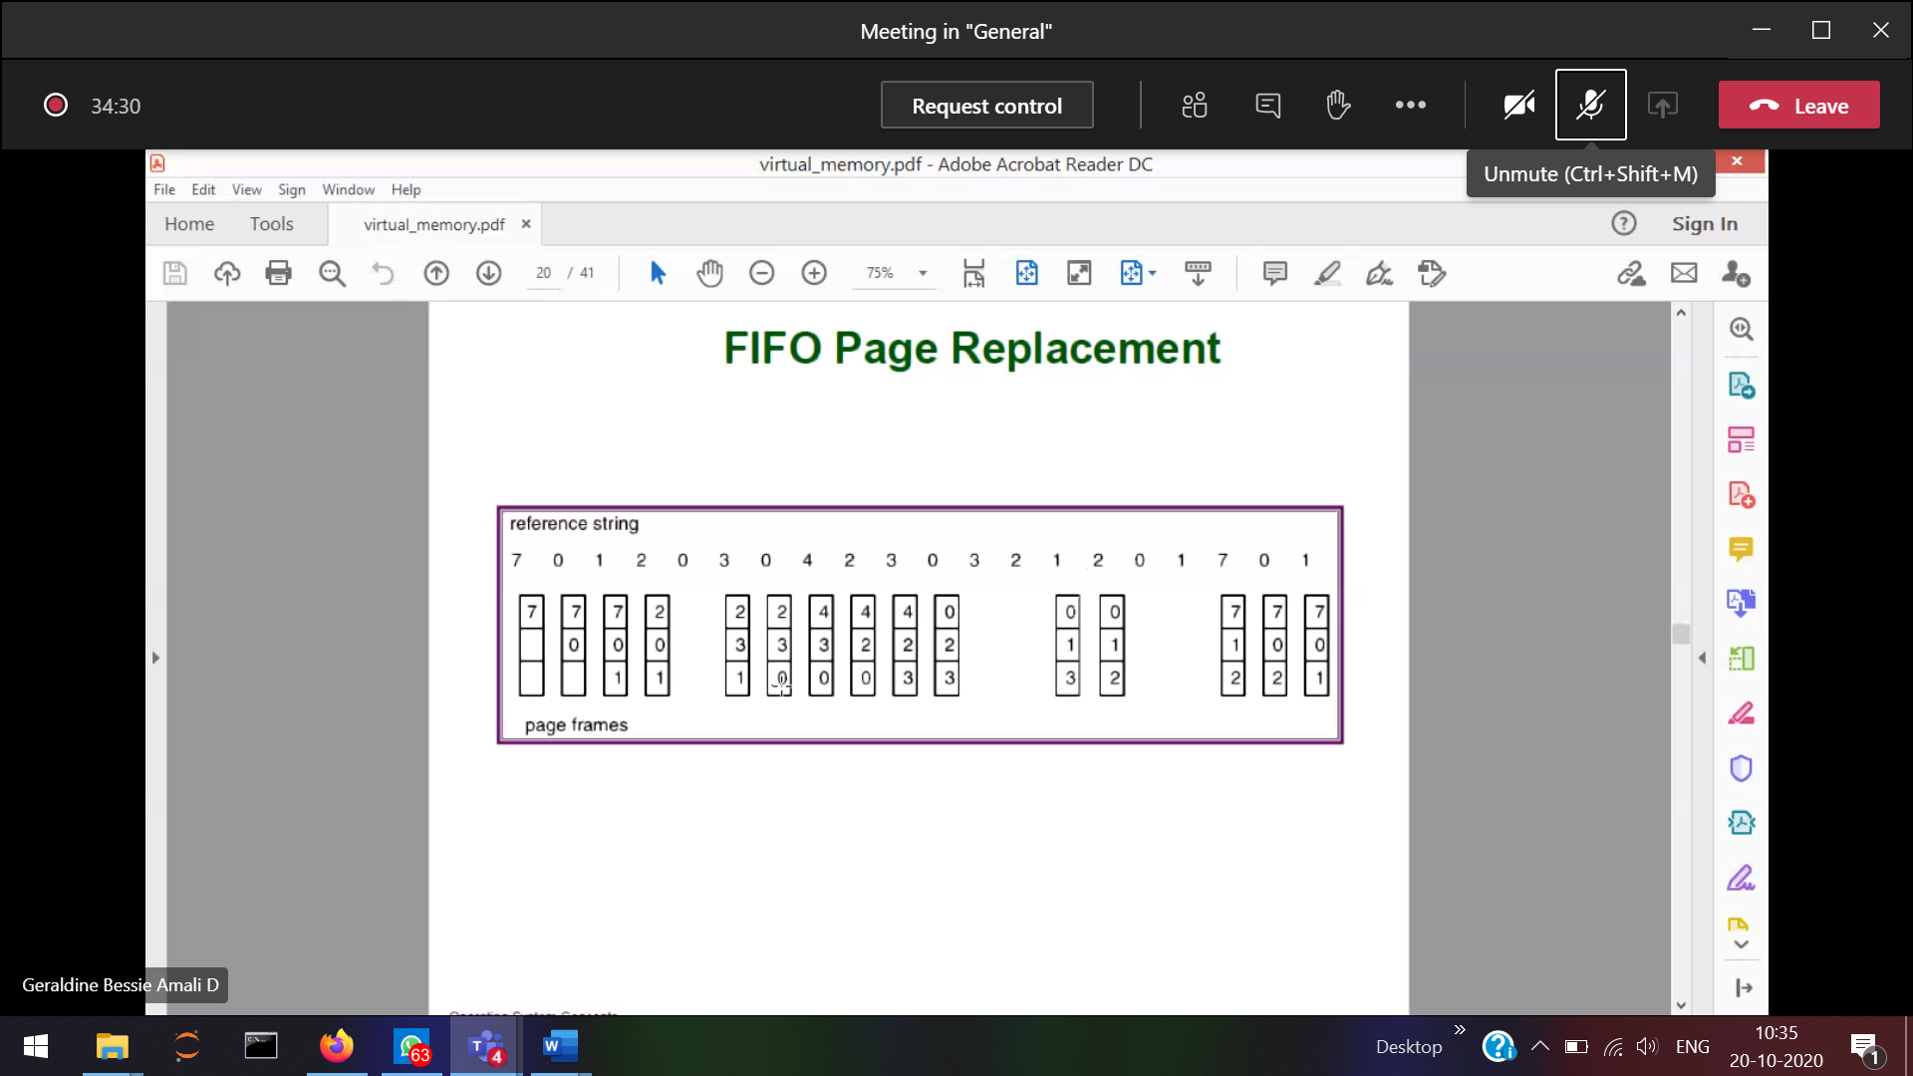

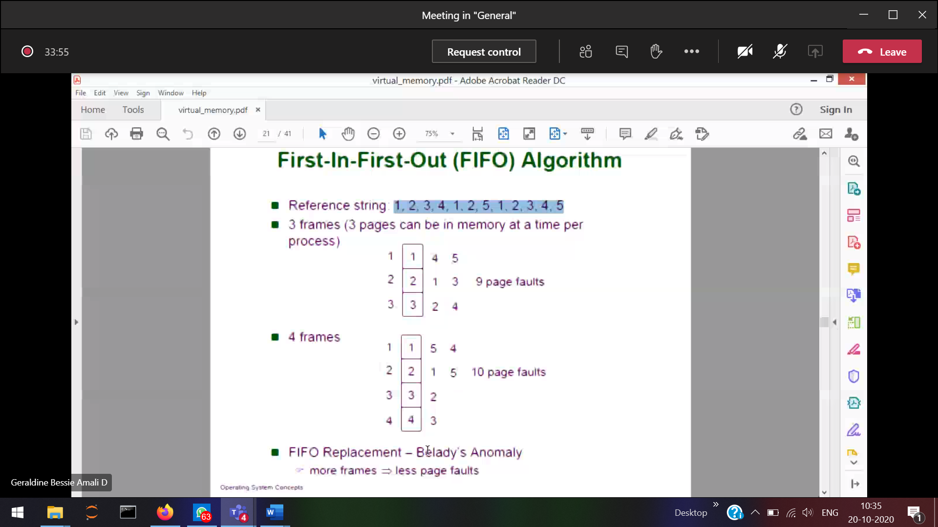

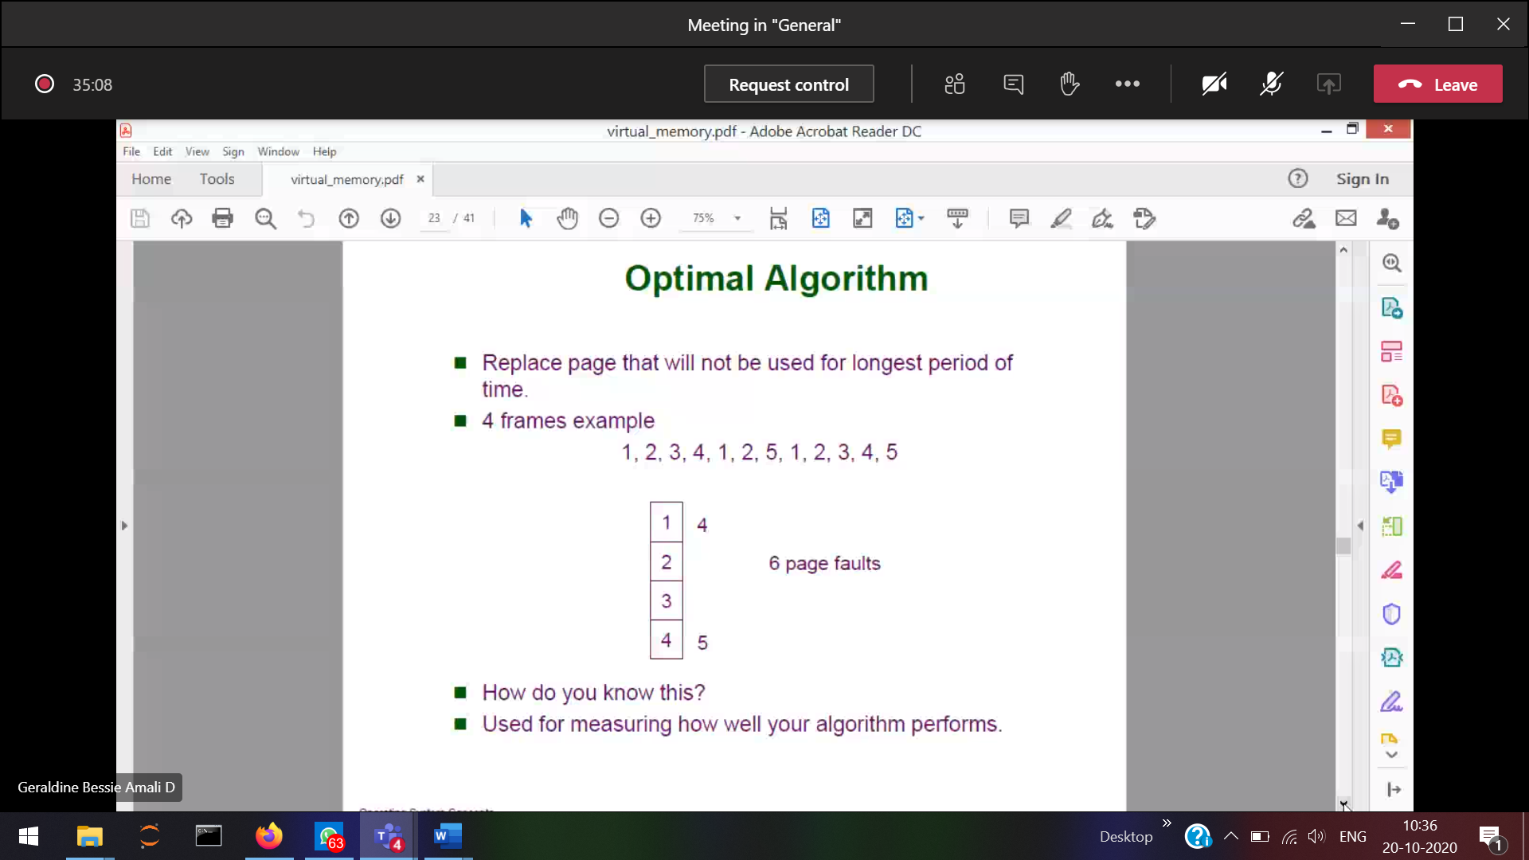

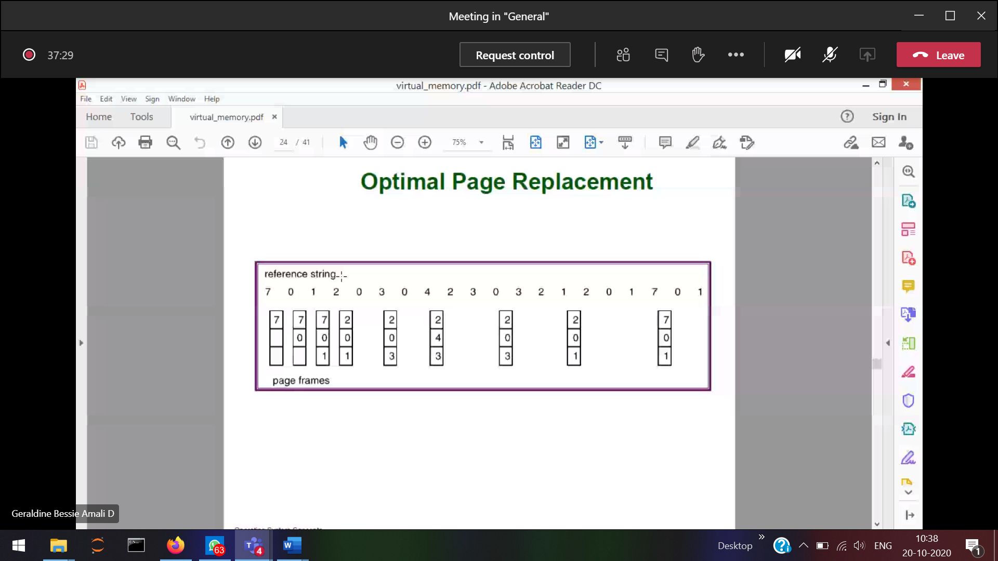

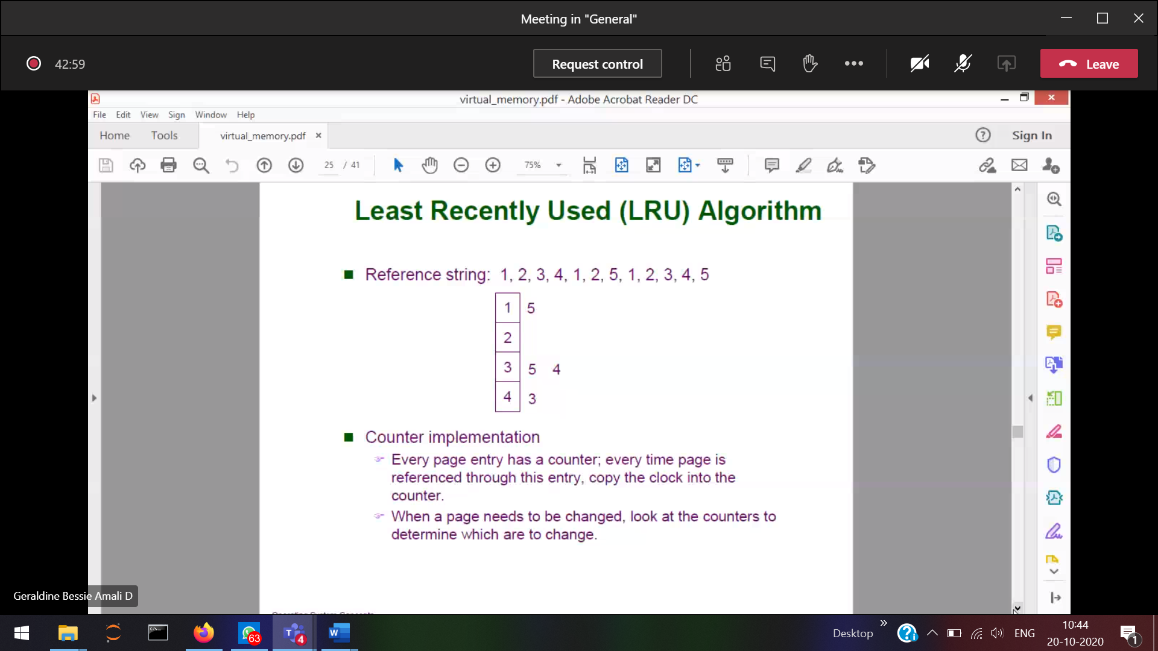

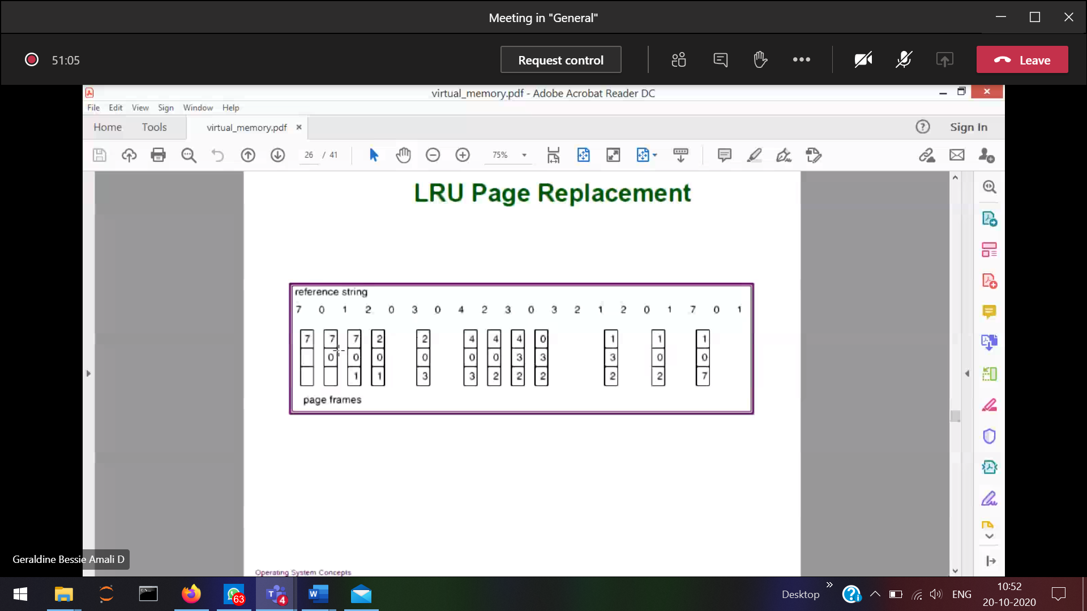

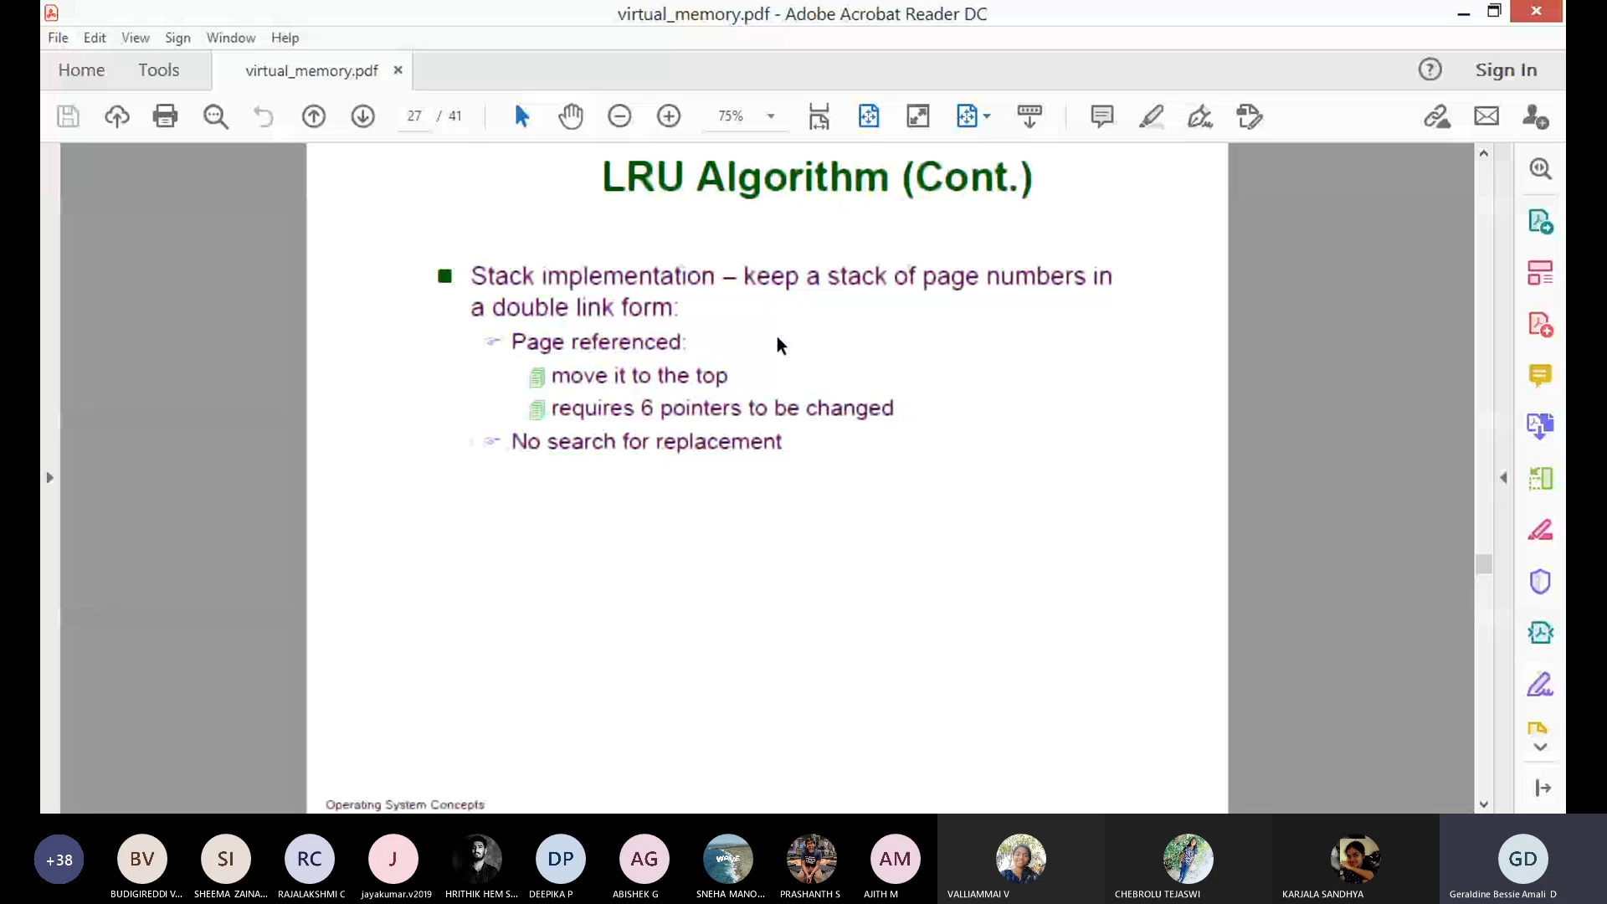

If I use stack for LRU algorithm, which element of the stack you will replace???  
either top/bottom??

Ans 🡪 bottom (since bottom was referenced long time ago)

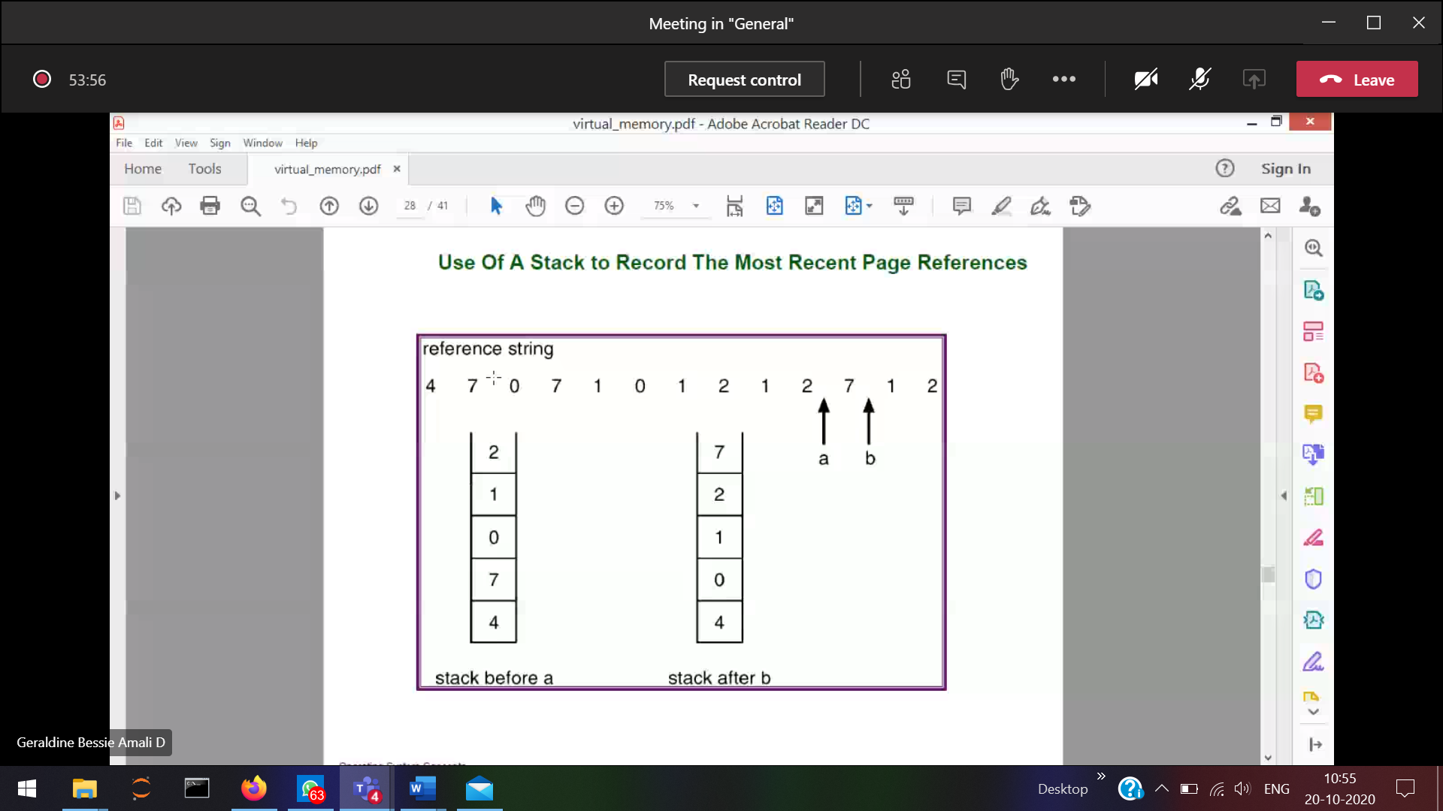

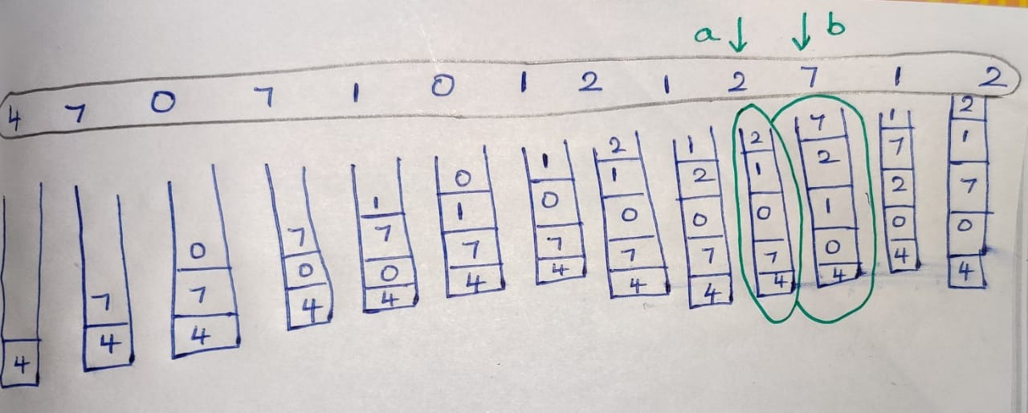

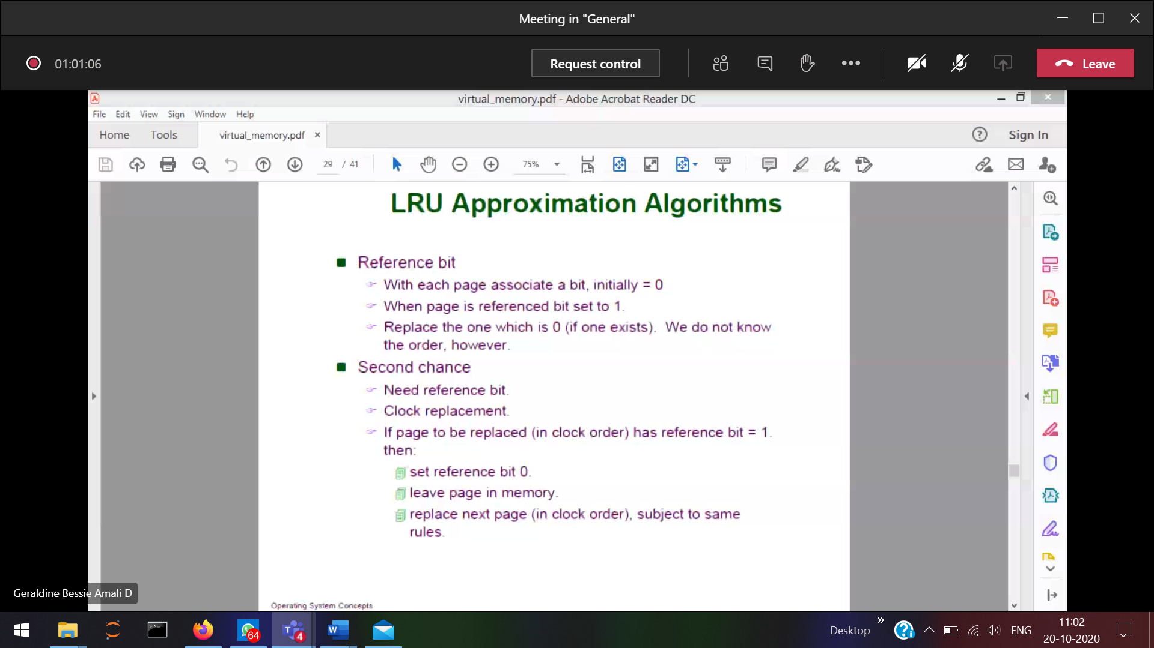

**Reference bit :**You will have the reference bit associated with the pages.  
Initially reference bit 🡪 0  
When-ever a page is referenced, reference bit 🡪 0  
When-ever a page is not referenced, reference bit 🡪 1

When you want to find the victim frame, go to the pages and see the reference bit which is 0 and replace it

Flaw:

Don’t know which one was referenced again and again.  
Don’t know in which order the pages was referenced.  
Don’t know which one was referenced long way back.

**Second chance:**Reference bit.  
Clock (since we don’t know the order in which the pages are referenced).  
You will have the reference bit, clock associated with the pages.

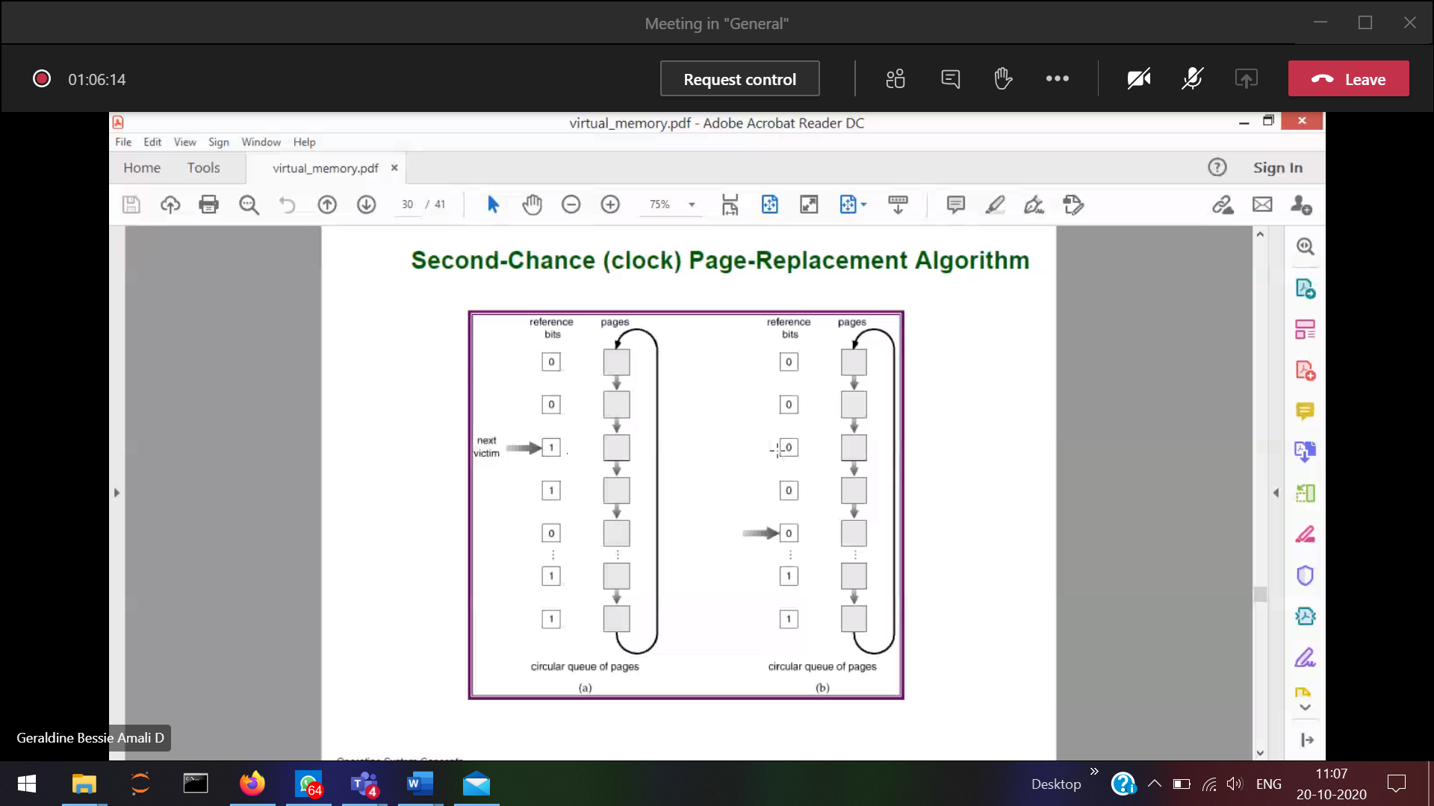



Where-ever there is a pointer, then that corresponding page will be a victim page.­­

1)According to the clock this has been the victim page.  
2) If a reference is made to the victim page,   
 reference bit 🡪 1, since the page has already been referenced there might be another chance that the page will be referenced in the future. So give the page a second chance. How?????

Change the reference bits🡪1 and reset the clock to the present time.

**Second chance Page replacement Algorithm (First-in First-out)**

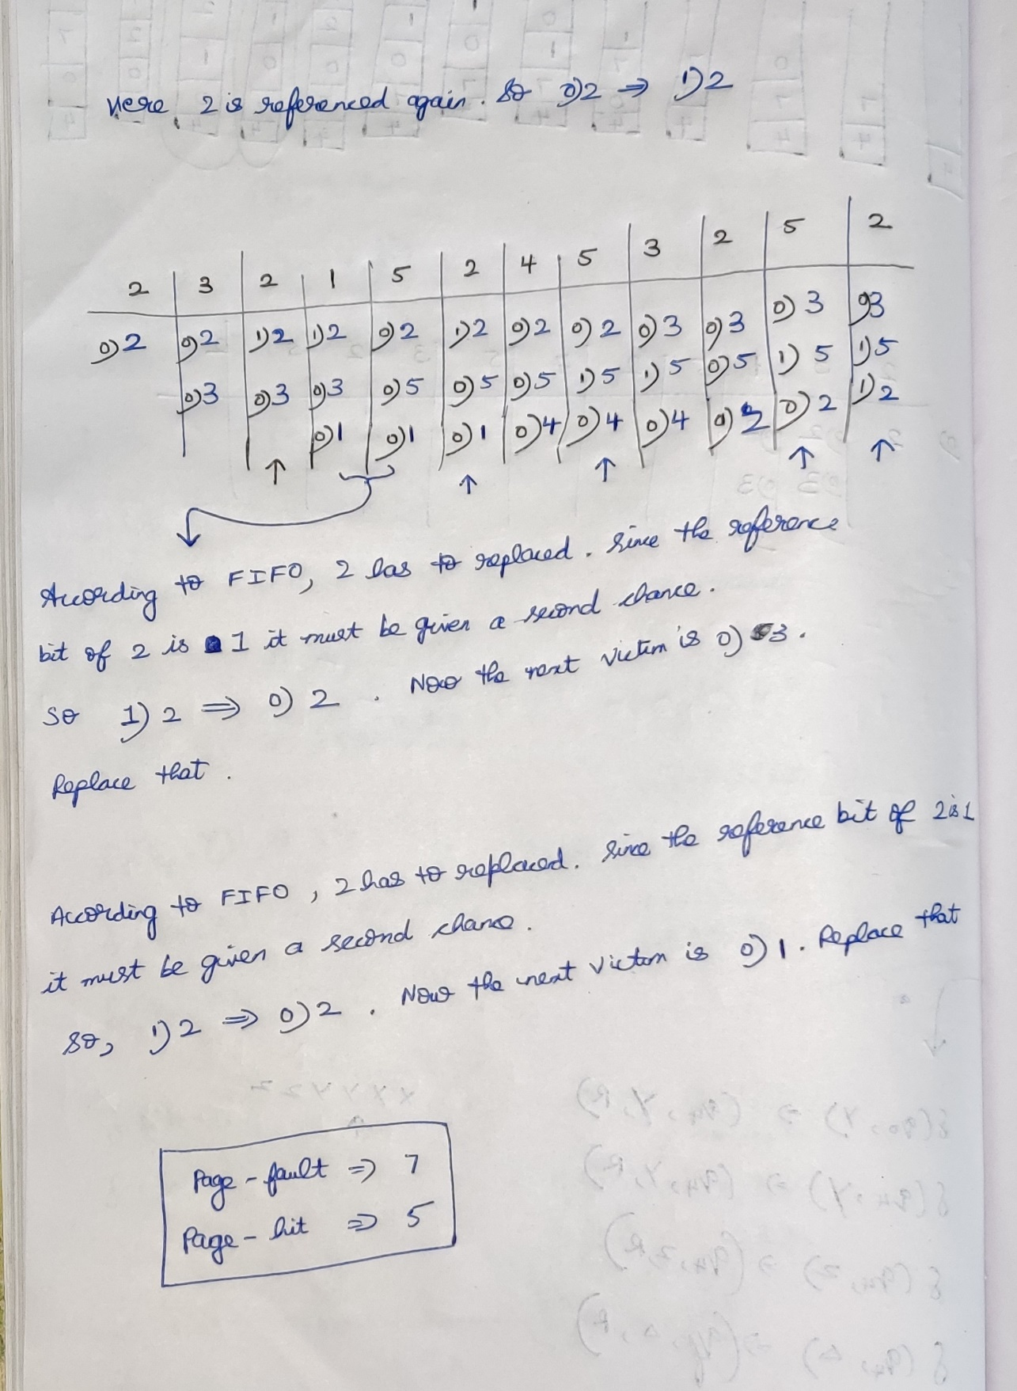

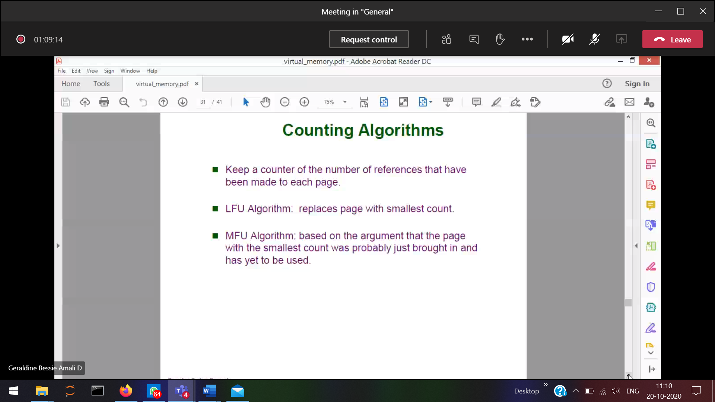

Counting algorithm 🡪 How many time it has referenced

LFU 🡪Replaces the page which has the Smallest count (Initialisation module)

MFU 🡪 Replaces the page which has the largest count

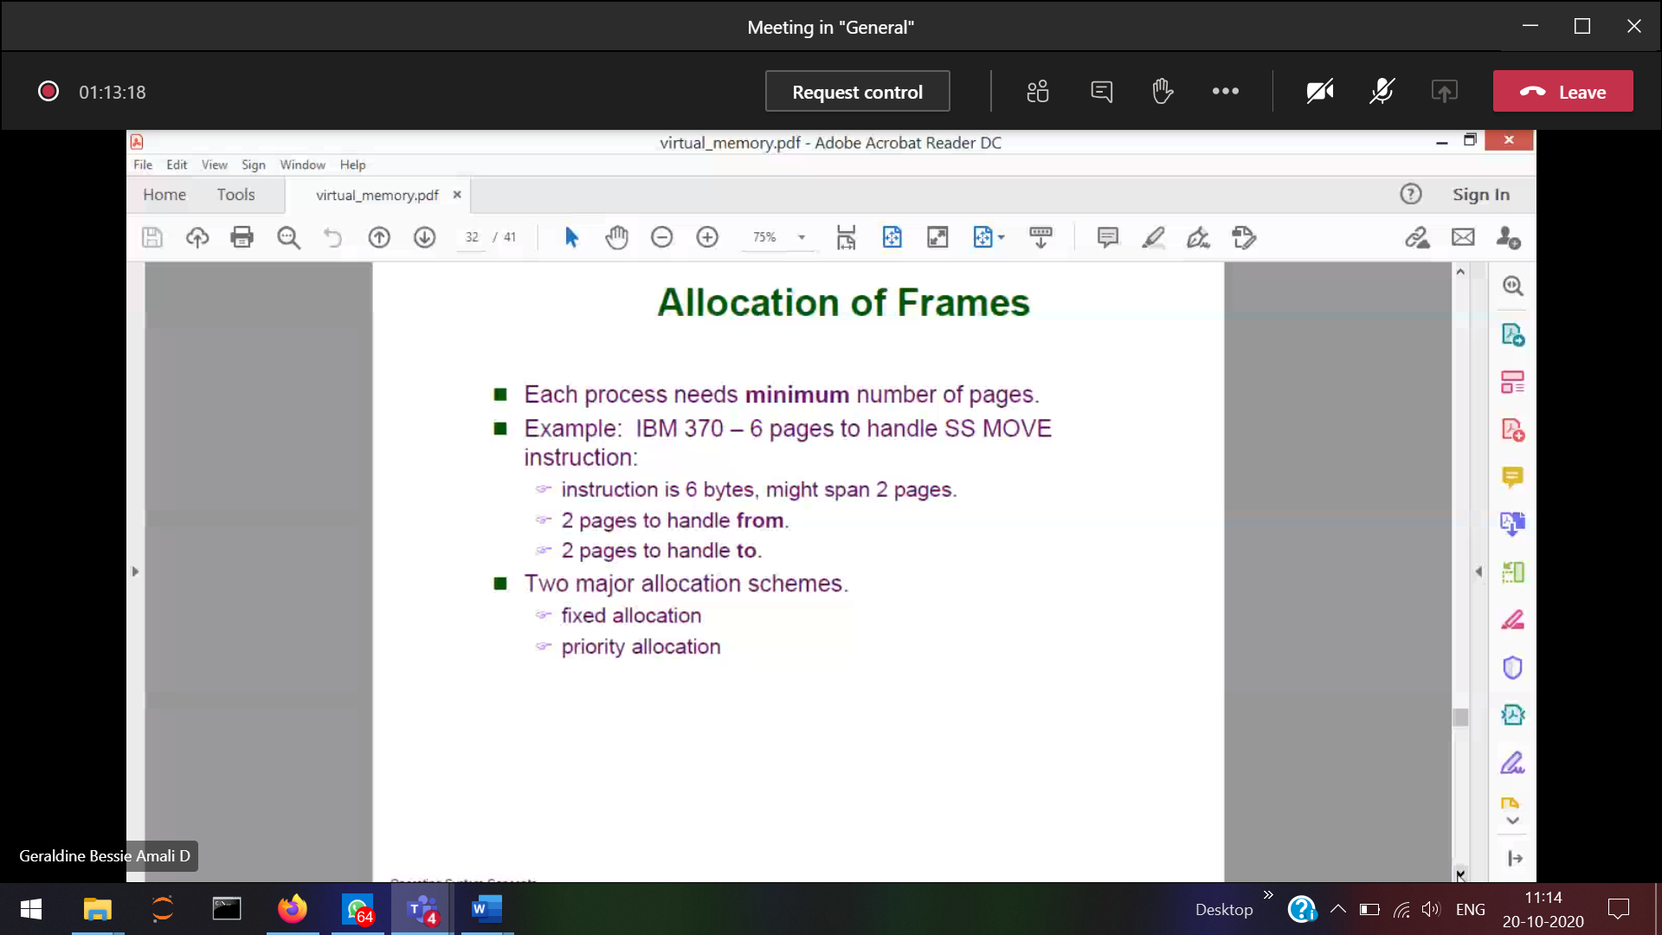

How many number of frames does a process requires???  
How the OS decides how many frames a process requires???

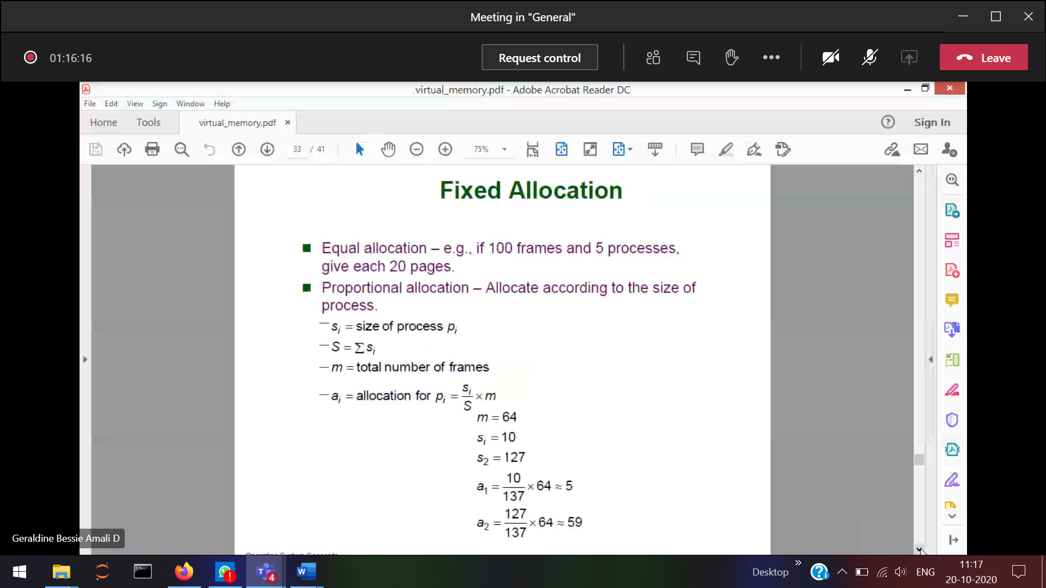

**Fixed Allocation**

1)Equal allocation  
Disadvantage 🡪 if the process requires less pages 🡪 allocated pages will be wasted.

2)Proportional allocation: (Allocate the frames according to the size of the process)  
Small process 🡪 small number of frames  
Large process 🡪 large number of frames

In equal allocation:  
(32 frames) p1 🡪 10 (10, so 22 wasted)  
(32 frames) p2 🡪 127 (127, not available)

**In Proportional allocation:**si 🡪 size of each process pi  
S 🡪 total size of all the processes   
m 🡪 total number of frames

Ai 🡪 total number of frames allocated to the process pi

5 frames for process1 and 59 frames for the process-2

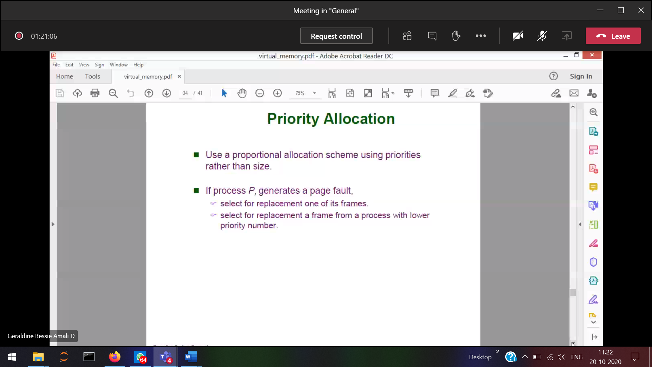

High preiorty process 🡪 larger number of frames

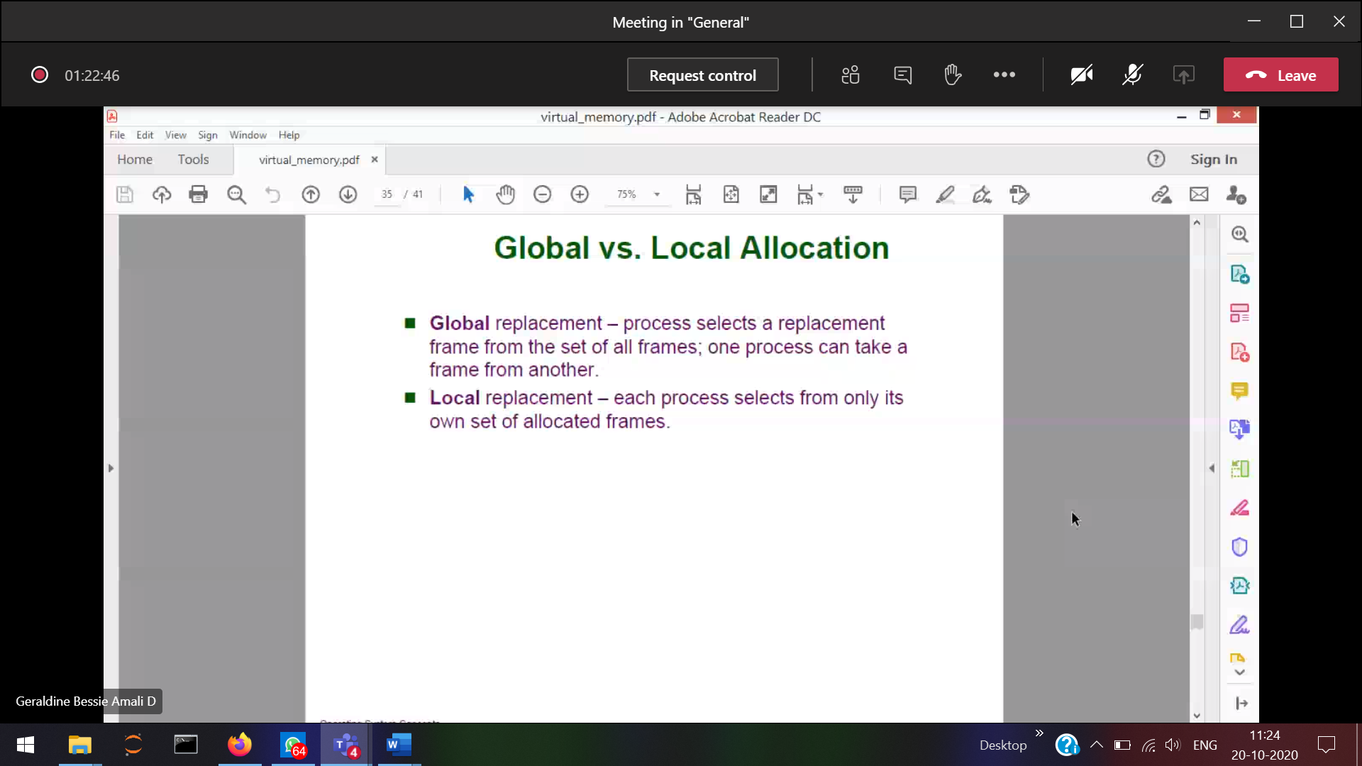

Global 🡪 CPU utilization much more.  
Local 🡪 CPU utilization is less.

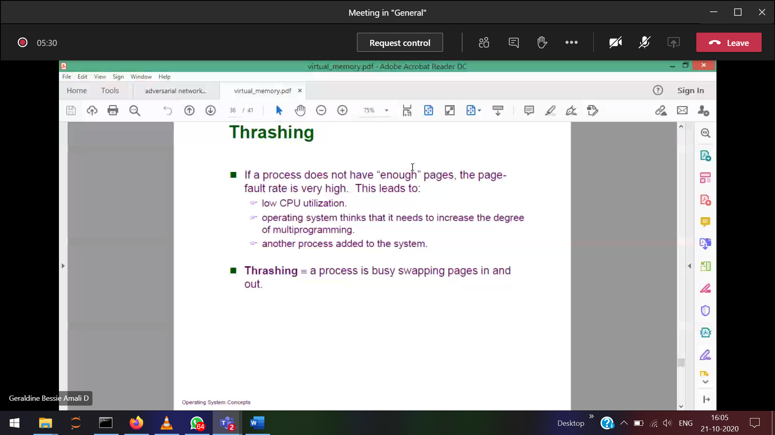When the CPU is not doing any progress, just swapping the paging in and out.  
There is no enough frames for the process.

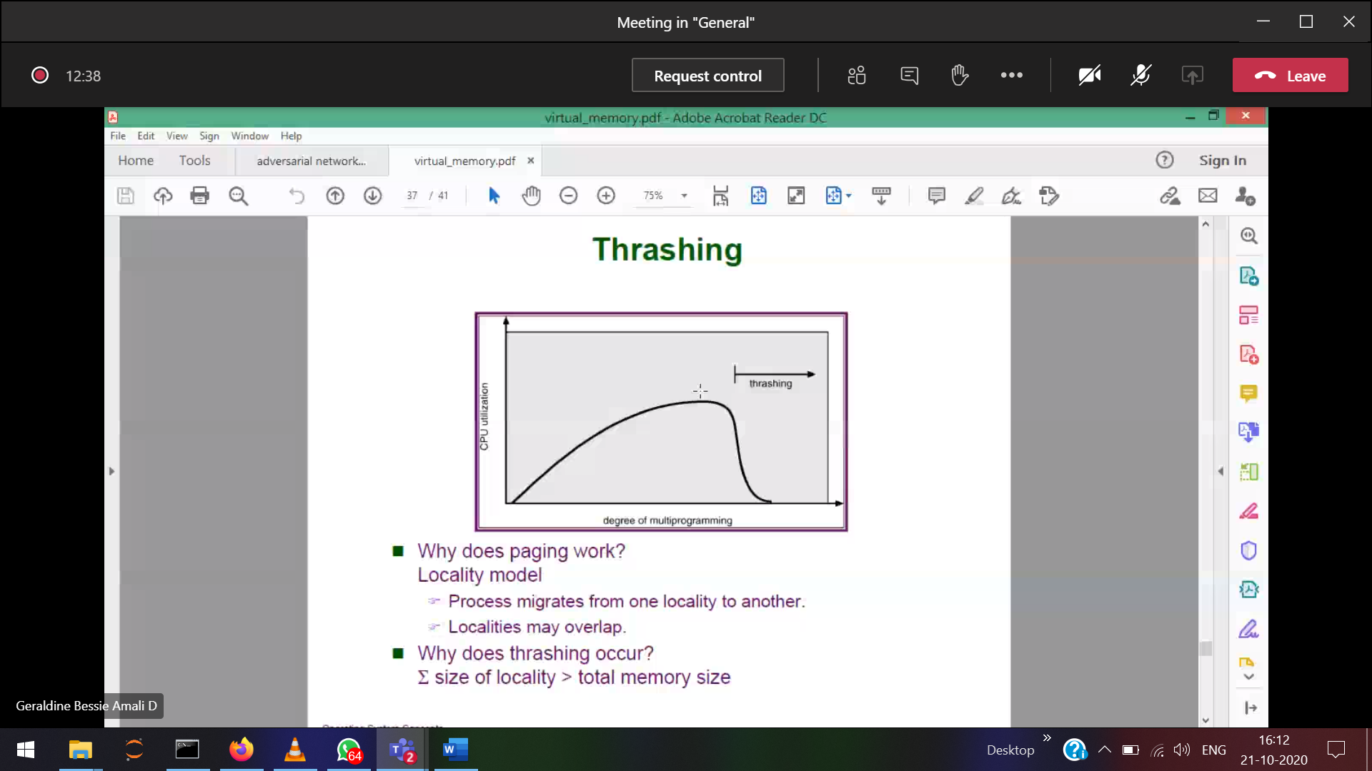

How many frames are given to a process to avoid the thrashing???

When the locality the demand for the process changes

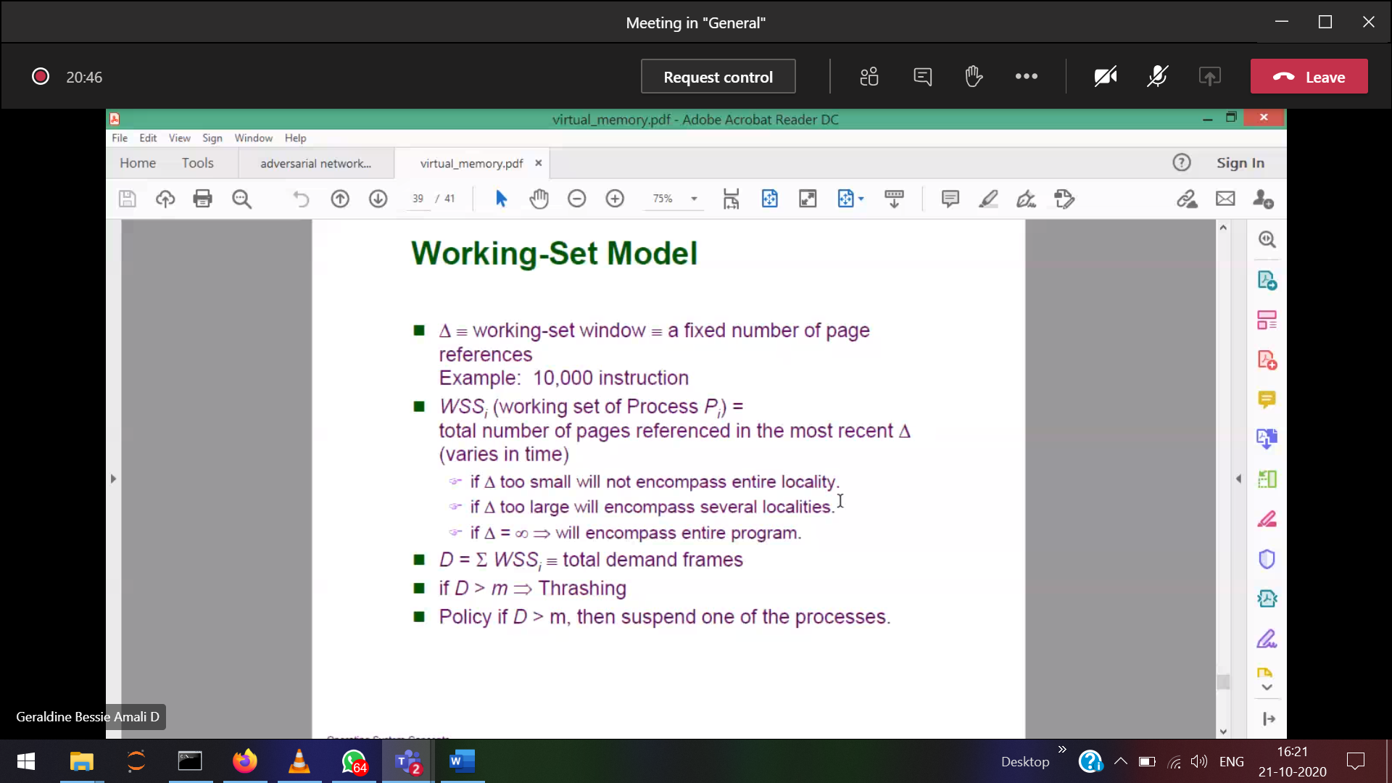

Page references 🡪 reference strings

If demand>allocation 🡪 thrashing

